The first steps to start with the e-learning system Moodle are as follows:
- Go to this page in your browser https://moodle.bstu.by/?lang=en;
- Enter the system (click “Log in”) to start working with Moodle. Note that course participants (both teachers and students) must be already registered as Moodle users, that is, to have an account in the system;
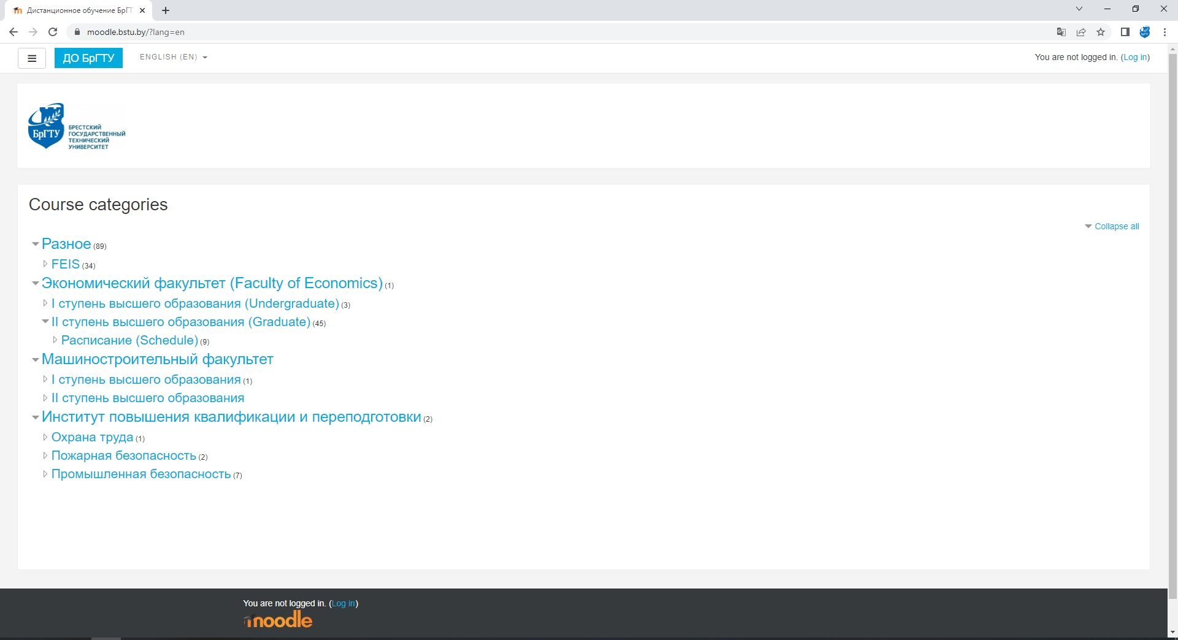

Figure 1. Appearance of moodle.bstu.by website

Editing a user profile
After you have logged in, your name is displayed at the top right corner of the page. It is highlighted as a hyperlink, by clicking on which you can go to the user's personal profile, an example is shown in Figure 2.
Some of the fields are not editable (they are determined by the system administrator during user registration and can only be changed by the administrator), but most of the fields can be changed by the user, so that you can update your information. Here are some of them:
- Email address. Enter an email address that you use regularly so you don’t miss any notifications from the Moodle system.
- Showing email address. Here you can choose the option when all registered users of the site will see your email address, or only users enrolled in the same course with you, or you can turn off the display of your email address altogether.
- User picture. If you upload your photo in this part of the profile, it will be displayed next to your name in the forum, in the list of users who are online, and of course in your user profile. To upload an image to the site, use a photo file in one of the following formats (for example, JPEG or PNG): simply drag it from the file manager to the area marked with a blue arrow.

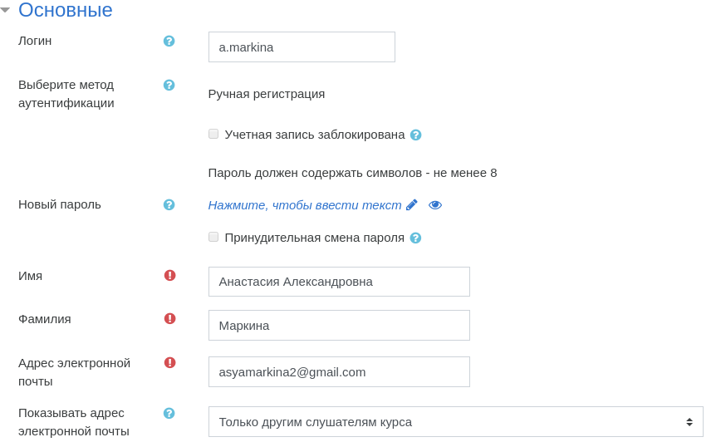
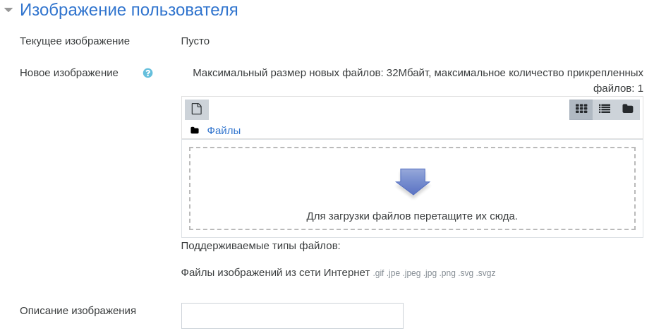

Figure 2. Editing a user profile

Moodle page layout

The pages of the Moodle system are arranged according to the block principle. The central part contains the content of the e-course or other working content, and the left panel contains “functional blocks” responsible for navigation, settings and the main menu.
The central part of the page displays the basic information that the user works with. So, when you log in, you need to select the desired course on it: clicking on the picture under the name of the course leads to a transition to the page of the selected course. Further, the content of the selected course with its thematic sections will be displayed in the central block of the page (Figure 3), and on the left – functional blocks, including the table of contents of the course opened in the central block.
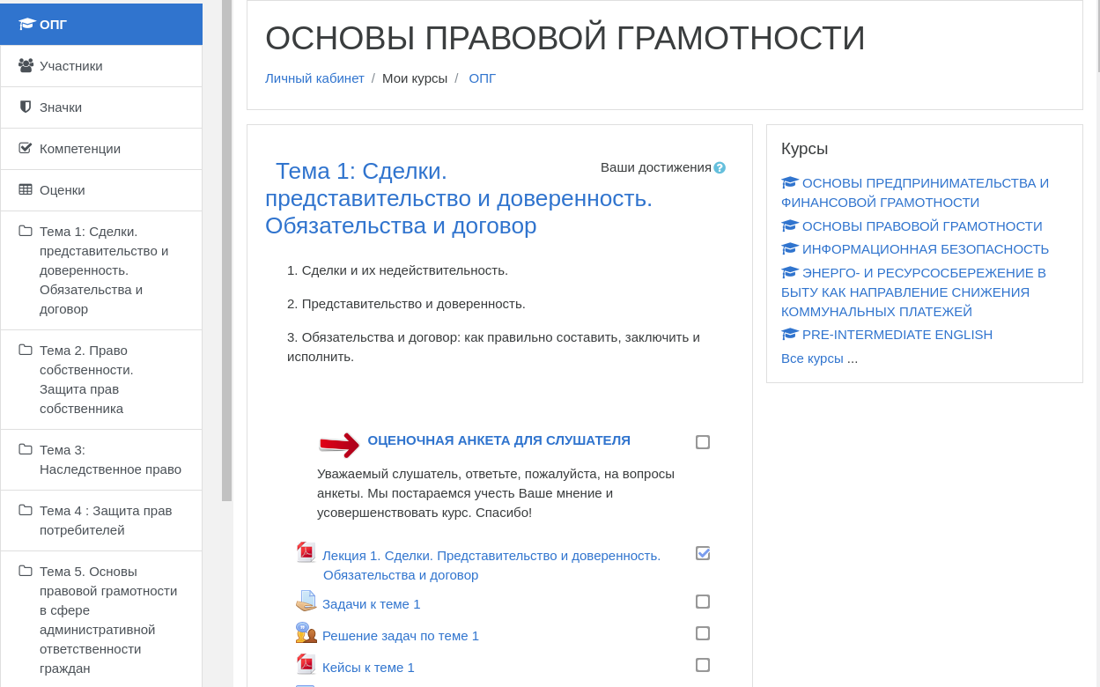
Figure 3. Course main page

Let's take a closer look at the most useful elements of the left panel.
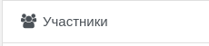
Figure 4. “Participants” menu

Participants. By selecting this menu (Figure 4), you can go to the alphabetical list of all course participants. There you can open individual profiles of users subscribed to the same course as you. You can also conduct personal correspondence with other course participants or the teacher in the built-in messaging system. To do this, open the member's profile and click on the following button:
Figure 5. Send a message

Grades. Here you can see a report on your work (Figures 6, 7).
Figure 6. “Grades” menu

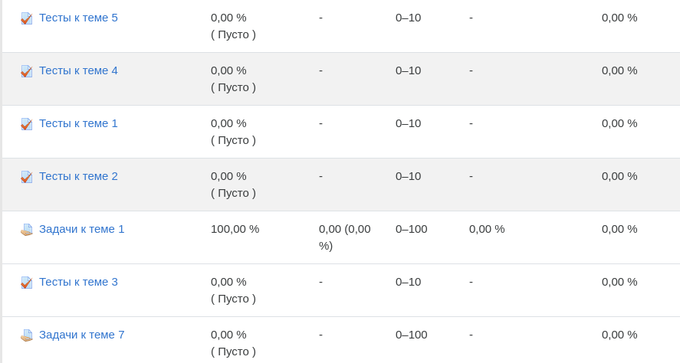
Figure 7 “Grades” page

In addition, you can view all final grades for all courses you are registered for (Figure 8).
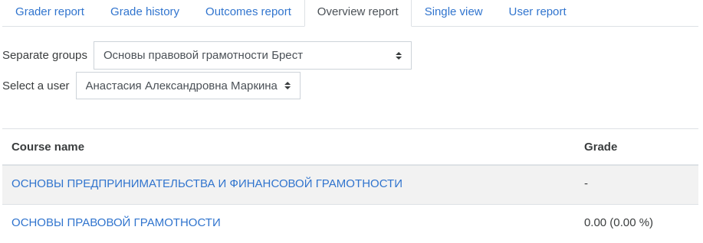
Figure 8. General report

Course topics are hyperlinks that reveal their content to facilitate quick access to course materials.
Navigation block. This block (Figure 9) contains several elements related by their functional purpose.
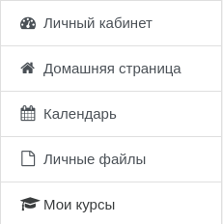
Figure 9. “Navigation” block

The most useful of these are the following two.
Menu “My courses” allows you to go to the list of courses for which you are enrolled.
Menu “Calendar” allows you to go to the built-in calendar page, which will display information about all the events that should happen soon within the education courses.

Communication in the Moodle system
Moodle provides course participants (students and teachers) with a choice of several different ways to communicate. The main means that allow system users to communicate with each other are the forum, email, and chat (instant messaging).

Forum
Forums allow course participants (including teachers) to communicate in a manner similar to forums on Internet sites (Figure 10). The forum is a convenient way for you to ask questions, as well as see what you've answered in the past to other members’ questions.
Also, forums allow you to hold thematic discussions within the framework of the training course: the teacher can ask a question, which you will be asked to answer. At the same time, you can also view the answers of other course participants in the same way (as opposed to individual assignments, which will be discussed later).
Taking part in the discussion on the forum, you must follow the rules of etiquette, as in any public speaking.
To participate in the discussion on the forum, you need to follow the link with the corresponding element of the course (Figure 10).

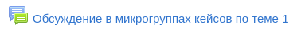
Figure 10. Element of the “Forum” menu

The forum page displays its name, explanations, links to the topics discussed (Figure 11). For each discussion, the list shows the topic, number of replies, data about the authors and dates of the first and last messages.
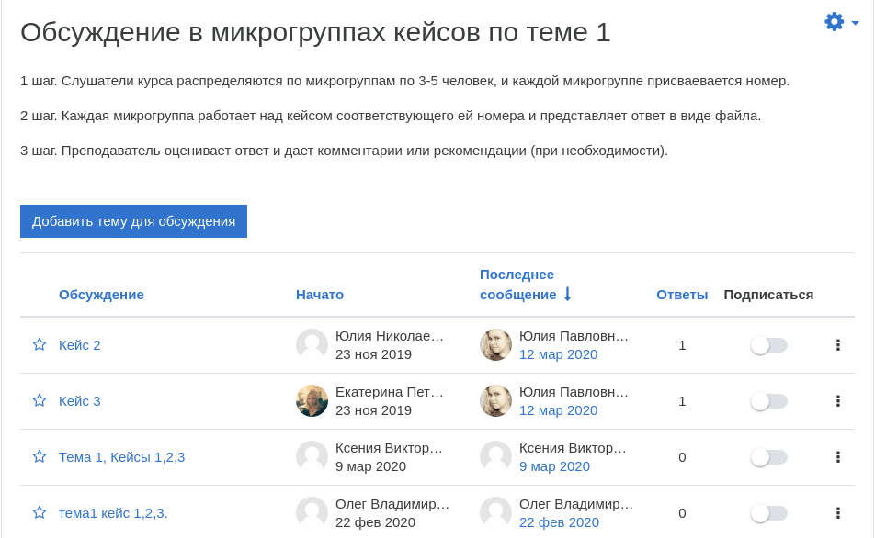
Figure 11. Example of “Forum” page

In order to take part in the discussion, you must go to the relevant topic and click the “Reply” button.
When replying, a new “message” is composed, in which the text of the reply is entered, and you can also attach a file (as in email). When the message is written and sent (by pressing the “Submit to the forum” button), within 15 minutes, it can still be corrected using the “Edit” option.
You can also create your own discussion topics. To do this, on the page shown in Figure 11, you need to click the “Add a topic for discussion” button. Next, in the “Subject” field, you need to enter the text of the subject of the message, and in the “Message” field, enter the accompanying text. If necessary, you can also attach a file to the message that opens a new topic.

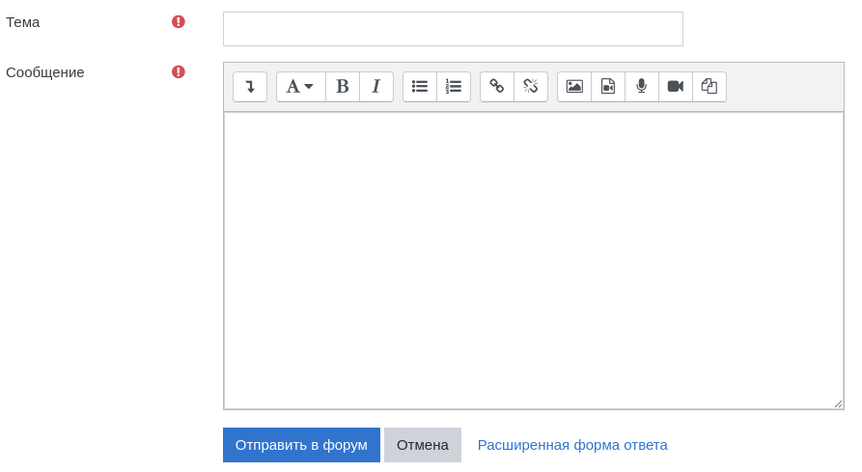
Figure 12. “Add a topic for discussion” page

Tasks and tests
An important part of the e-learning course is the test control of the understanding of the material, as well as the practical tasks.

Task “Answer as a file”. When completing assignments that require the provision of an answer in the form of a file (Figure 13), you are dealing with a task set by the teacher, which must be answered in electronic form, i.e. upload your document with the solution to the system (presentation, text, picture, etc.).
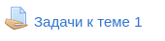
Figure 13. Element of the menu “Task in file or text format”

After you have uploaded the solution to the task, the teacher gets access to the uploaded file, evaluates the answers given in it, and can leave a comment on them. At the same time, grades for completed tasks appear on the site (the files with the tasks themselves are also saved).
In order to send a file with the solution – the answer to the task – to the teacher, you must click on the “Add answer to the task” button at the end of the page (Figure 14).

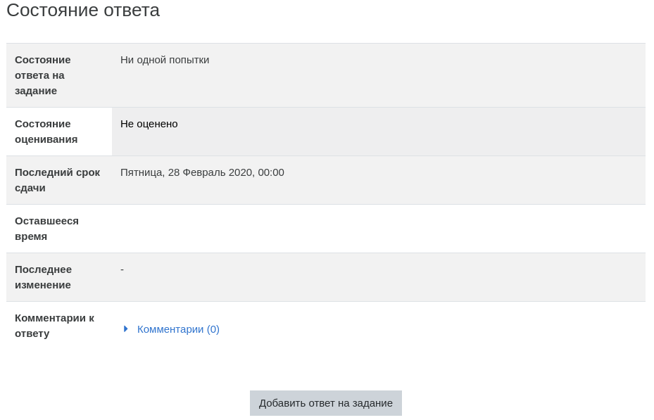
Figure 14. Button “Add answer to the task”
Next you will need to upload the file to the system (Figure 15).
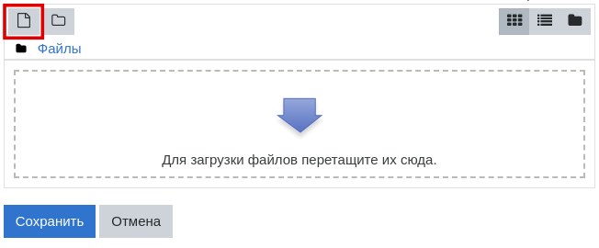
Figure 15. Upload a file
Note that only one file can be used as a response to a task; if you try to submit another file as a response to the same task, the previous file will be replaced by the new one.

Task “Answer as a text”. This option is similar to the previous one. The difference is that the answer needs to be written not in a separate file, but in the built-in editor.
This uses a standard text editing field (built into the Moodle system), similar to an ordinary text editor. To enter an answer, after pressing the “Add answer to the task” key, enter the text of the task in the “Answer as a text” window and save the answer.
Depending on the settings, tasks of this type may allow editing the response text after it has been submitted.

Test. The Moodle system provides a wide variety of forms of knowledge control. Depending on the settings, when passing the test, a time limit can be set (after a specified period, it automatically ends, and the selected answers are sent for verification), and the number of attempts to pass. Also, the test can always be available, or only in a clearly defined range of dates and times. The order of the questions in the test and the order in which the answer options for each question are given can automatically change each time you try to take the test.
To start testing, click on the name of the required test (Figure 16).
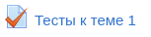
Figure 16. Element of the “Test” menu
Depending on the settings chosen by the course creator, various additional information can be displayed on the test page: the number of attempts, the time allotted for testing, the deadlines for passing, the assessment method for multiple attempts (Figure 17).
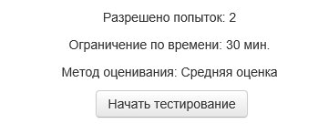
Figure 17. Start a test

After pressing the “Start a test” button, a menu will appear with a confirmation button to start trying to pass the test (Figure 18).

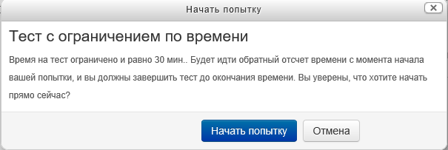
Fiugre 18. “Start a try” box
After confirming the start of the attempt, you go to the test page. The test questions are displayed in the central part of this page. Attention should be paid to the explanation in the text of the questions, for example, the number of answers to be selected (Figure 19).

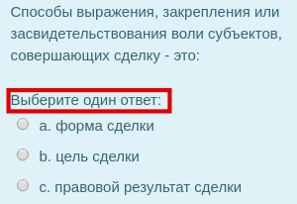
Figure 19. Example of the “Multiple choice” question with one answer

The side of the page shows the number of questions in the test (with the ability to navigate through them, for example, to return to one of the previous questions) and the time remaining for testing.

After completing all the tasks, you must click on the “Finish the test” button. The system will ask for confirmation of this action (Figure 20).
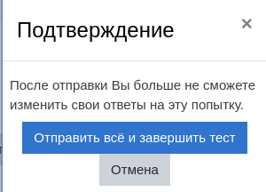
Figure 20. Results of the try box

After confirming the completion of the test, you go to the page of the results of your test. There will be displayed information about passing the test, the points received, the assessment. The score is expressed as a percentage (share of points from the maximum possible) (Figure 21). An analysis of the test can also be displayed there, indicating the correct and incorrect answers you made, and pre-made comments.
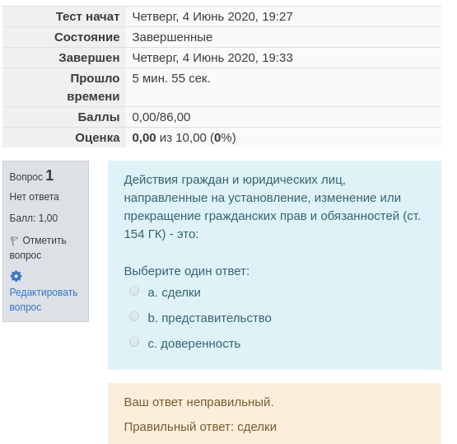
Figure 21. Test results box

Lecture. The lecture is a sequence of pages of educational material, alternating with control questions (usually at the end of each page of the lecture). Points are awarded for answers to control questions.
To go to the desired lecture, click on its title.
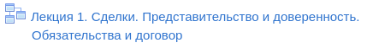
Fiugre 22. Element of the “Lecture” menu

After studying the material of on one page of the lecture and answering the control questions, use the navigation button to go to the next page (or return to the current one, depending on the correctness of the answer).
Points when working with a lecture are awarded only for correct answers. In addition, if the lecture has a question with a detailed answer (essay), then it is checked by the teacher, and the final score for the lecture is set after the essay is evaluated.

Glossary. The glossary in the Moodle system is essentially an electronic reference book of terms (Figure 23).
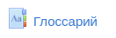
Figure 23. Element of the “Glossary” menu

Its main feature is that the Moodle glossary can be updated by students during the course (Figure 24). Having discovered a new concept for yourself (or having received a special task to replenish the glossary), you create a dictionary entry that reveals the concept or term (for this, you use the built-in text editor, similar to the one in which you enter answers to “task as a text”). Other students of the course can comment on the article, offer their own definitions.
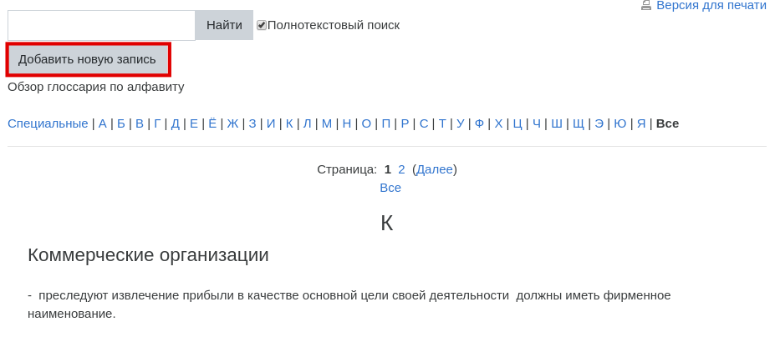
Figure 24. Structure of the “Glossary” element

Terms placed in the glossary will then be displayed in the texts of the course with the ability to quickly access the definition of the corresponding term.

